
3 Nickels and Dimes

Student Task Statement
Andre’s coin jar contains 85 cents. There are no quarters or pennies in the jar, so the jar has all nickels, all dimes, or some of each.
1. Write an equation that relates the number of nickels, the number of dimes, , and the amount of money, in cents, in the coin jar.
2. Graph your equation on the coordinate plane. Be sure to label the axes.
3. How many nickels are in the jar if there are no dimes?
4. How many dimes are in the jar if there are no nickels?
Activity Synthesis

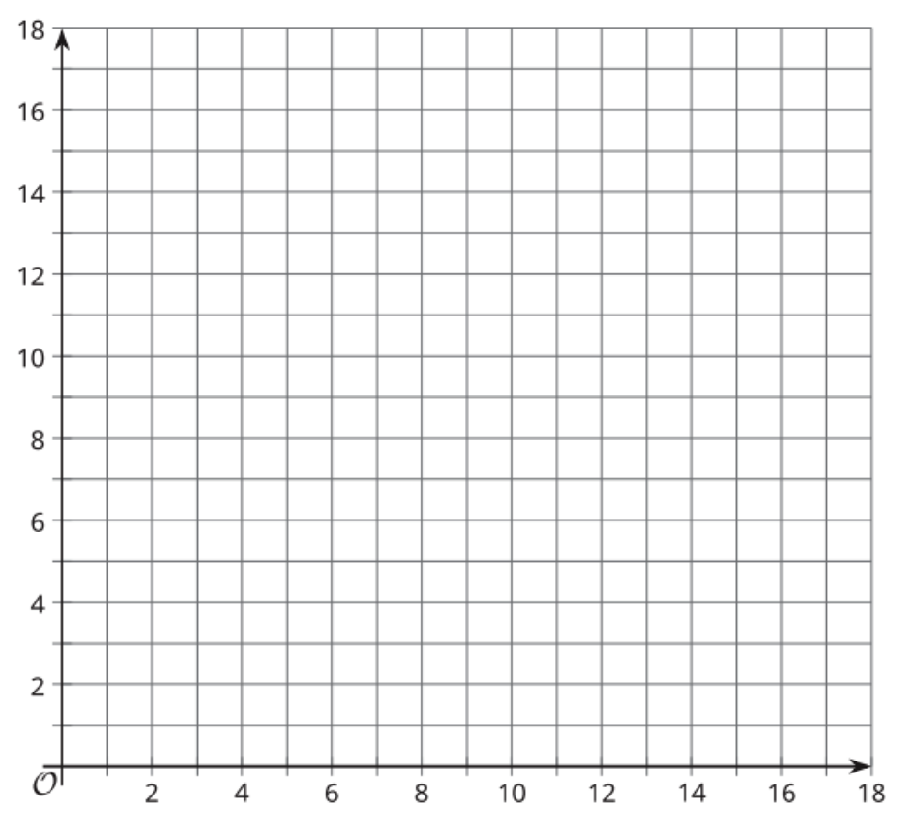

Possible Answers:
